COMPOSTING
MANUAL

February, 2015

This manual is realized in the frame of the project:“Composting practices in Dajçi Commune“ supported by Decentralization and Local Development Programme
This document is prepared by Decentralization and Local Development Programme (dldp), with financial support of Swiss Agency for Development and Cooperation (SDC)

This publication reflects the view of its authors and not necessarily of SDC.

Prepared by:
Milieukontakt International, Albania
Str: Xhorxhi Martini, P. Teuta Konstruksion; Shk.3/8, Tiranë, P.O.Box 1700, www.milieukontakt.org

Experts:
Andrian Vaso
Valbona Mazreku
Elvis Cela
Rrezearta Ago

With the Support of DAJC, BB Commune:
Arben Gjuraj and Ernest Lukaj

Published by:
Decentralisation and Local Development Programme (dldp)
HELVETAS Swiss Intercooperation | Albania
Address: Str. "Ibrahim Rugova",
PLUS Building, 2nd Floor / No. 3. Tirana | Albania
www.dldp.al | www.km.dldp.al

CONTENT

- ABOUT MANUAL

  - Objectives and benefits from Manual
  - Target group
  - Methodology of Manual
  - How to use Manual

- INTRODUCTION

  - What is compost
  - Why compost
  - Benefits from compost

- LEGAL FRAMEWORK FOR WASTE MANAGEMENT; POLICIES AND REGULATIONS
3.1 Relation with waste management scheme of the commune
3.2 Policies and rules for composting

- KOMPOSTING, TECHNOLOGY AND ITS TYPES

  - Composting process

    - What happens during composting
    - Factors affecting the composting process
    - Changes of materials during composting
    - Conservation

  - Materials for compost

    - What to compost and what not
    - Equipment for compost

  - Methods/ Types of composting

    - Pasic composting of manure piles
    - Composting in the palette
    - Composting in in the country – decomposition of ventilated (individual)
    - Composting in landfills airy (the three- quadruple)

  - Technology of composting / Activities associated with composting

    - Depozit/ storage and handling of raw materials
    - Shredding
    - Blending and formation of piles, pallets
    - Konservation, storage and compost treatment
    - Screening
    - Drying
    - Packing

- MANAGEMENT OF COMPOSTING PLANT

  - Safety and health
  - Season and weather management
  - Individual composting vs compost at village lavel
  - Monitoring of process and solving problems

- ENVIRONMENTAL CONSIDERATIONS

- MARKETING
  - Product analysis
  - Market positioning compost farm
  - Assessment and Market Development
  - Potential users and products of compost
  - Bag versus Bulk Sales
  - Selling your product
  - Cost of composting

- ANNEXES
- Bibliography

- ABOUT MANUAL

  - Objectives and benefits from Manual
Improper management of waste is a global environmental challenge, because it comes directly from human activity unrestrained. This challenge affects the community and quality of environment in developing countries and emerging economies. However, the challenges facing countries in development, not necessarily are the same with those of developed countries. For Albania one of the challenges remains disposal of those wastes that can be recycled or reused. One of these trends is organic waste and green mass for rural areas.

Composting is a process that is recently seen more and more as a natural management practice, very positive for soil enrichment and addressing the problem of losses, erosion and reduction of negative impact on the environment due to the extensive practice of land use in the passed decades.

Producers and users of compost find in this manual information on what is compost and what are the benefits of its application. It shows composting methods and technology and how to address environmental sustainability and various problems with which farmers may face.

Management of compost involves many stages of the production process from the materials used, collection, method of construction, handling, use and its marketing. As such knowledge and advice on materials that can be composted and the one that should not be part of it, constitute an essential part for farmers in general and especially for farmers of Dajci, who for years think they producing compost for their personal needs, but the quantity and quality of it is poor. Different models or construction of pallets and care must be taken to minimize bad smells, leaks, presence of insects as well as other factors such as control of temperature, movement of materials, which occupy an equally important part in this manual.

Finally, marketing is very vital because although compost is a very effective nutrient for soil, which can reduce the need for chemical fertilizers, it does not guarantee a ready market. Market for compost is an interesting business opportunity for farmers providing valuable investments and identifies suitable products for accessible markets.

  - Target group
This manual is intended to facilitate farmers and local government units who want to extend the practice of composting in their rural areas aiming at a high quality of material and/or close the whole production cycle and use of compost.

  - Methodology of Manual
The manual is written in a simple language and is based on practices and results obtained during the pilot composting process in Dajçi commune.

  - How to use manual
Manual should be read as an important guide for all farmers but also for students and school childrens because it can serve as a good educational information and formative. In no way we do not pretend to have given all the techniques and methodologies that apply in the world but we are convinced that it is closer to Albanian realities and can be used and put into practice individually or in small community groups.

- INTRODUCTION

  - What is compost?
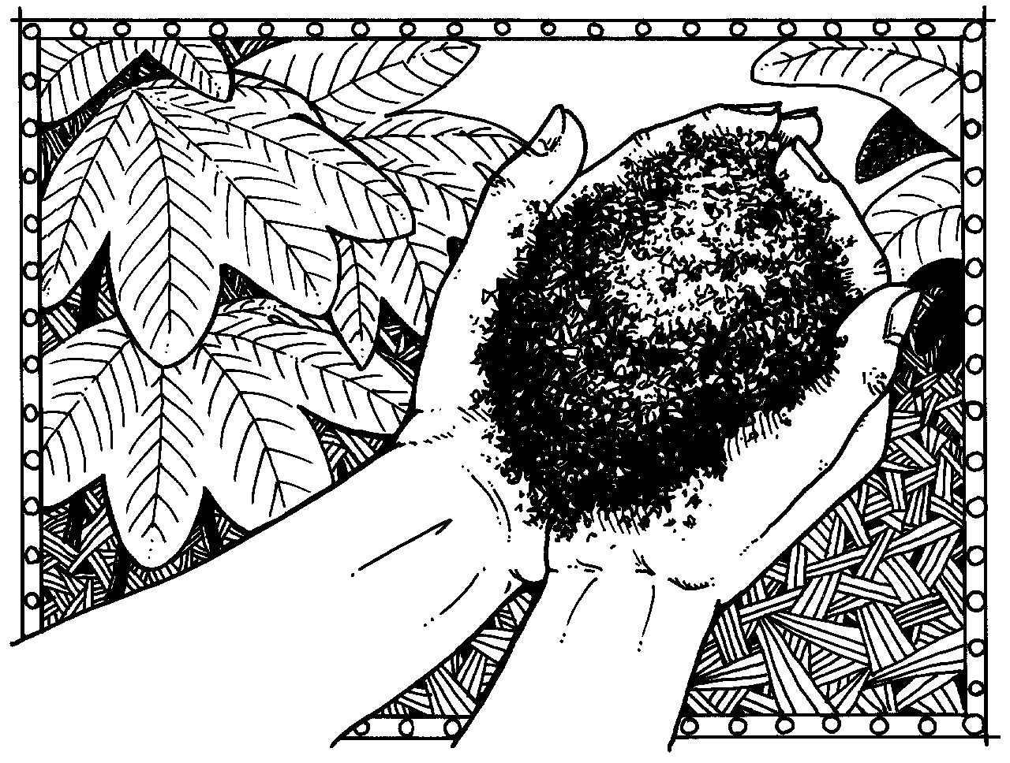
Composting is the transformation of organic material through decomposition in soil material called fertilizer.
Composting is the natural process of decomposition and recycling of organic material, conducted by aerobic microorganisms, which through a phase of high temperature leads to a homogeneous soil composition, rich and black, called compost. So, compost is a product of natural recycling. Invertebrates (insects and earthworms), and microorganisms (bacteria and fungi) help in this process.

Fig 2.1

Gardeners call it “black gold,” because it is so rich in nutrients and ads so much value you when add it to your soil. Finished compost is also often called humus, but usually only in really serious sounding books written by uppity, academic types.

Composting is the biological decomposition of organic matter under controlled aerobic conditions. In contrast, the fermentation is anaerobic decomposition of organic matter. In the right conditions, bacteria and other microorganisms quickly break down organic material into rich, fertile earth that you can add to your soil to increase its fertility and health. Composting is cheap and easy to learn, but there is a little bit of an art to it that comes with practice. Breaking down waste requires the right amount of moisture, heat, soil aeration and a proper mix of materials.

  - Why compost?
Composting makes possible the return of organic waste in fertilizer for the land. If you pay a fee for waste management in your community, composting will save money and reduce the costs of fertilizer, irrigation and pest control. You also save time by providing optimal conditions for microorganisms. Compost not only adds nutritional value to the ground, but increases its ability to retain water.
Composting as a process has multi direction benefit as:
- Është i qëndrueshëm në kohë dhe i pasur me humus, pa erë ose me erë të pranueshme.
- Reduces the amount of waste in deposit by about 30-35%;
- Reduces or enables biological processes in deposits;
- Affects in decreasing the use of fertilizers and pesticides;
- Reduces pollution from extra use of fertilizer barns and other waste;
- There are very large microbiological qualities and organic structural.
- Affects the improvement of physico-chemical and biological soil fertility, helping air circulation, bringing beneficial microorganisms for healthy growth of root system of food crops;
- It is stable in time and rich in humus, odorless or the smell is acceptable.

  - Benefits from compost?
Compost is an inexpensive alternative to chemical fertilizers, and it is less likely to harm sensitive roots. Many chemical fertilizers are made from petroleum and other non sustainable sources. The price of chemical fertilizers seems to get higher every year due to rising oil and shipping costs. On the other hand, compost doesn’t use any oil and doesn’t require much transportation. Using compost reduces our dependence on foreign oil and boosts soil health.
Table below shows some of the reasons that compost is popular

The benefits of composting are numerous:
  - Improves soil characteristics;
  - Low cost of production;
  - Easily used;
  - Guaranteed quality of compost and substrate;
  - Sufficient for the needs of the plant with nutrient;
  - Higher yields biological products;
  - Wise reuse of the organic waste and green;
  - Reducing the volume of waste;
  - Protection basic water;
  - Lack of bad odors;

Compost finds great use in horticulture and cultivation of seedlings, as the underlying substrate of cultivated land, to protect from the cold, as well as budding, plant food in different stages. Compost impacts on plant protection as well, control of pests, weeds and illnesses.

- The legal framework for waste management; Policies and regulations for compost

3.1 The legal framework for waste management
The principle of the right for integrated waste management is guaranteed based on internal legal framework and in some international documents ratified by the Albanian state. We find this principle specifically reflected on:

- Constitution of the Republic of Albania v.1998;
- Basel Convention on the control of transboundary movements of hazardous wastes and their disposal
- EC Directive 98/2008 on Waste
- National Strategy and Waste Plan adopted in 2010
- Law no. 10463, dated 22.9. 2011 "For Integrated Waste Management"
- Law No.8094 dated 03.21.1996 "On the public disposal of waste"
- Decisions of the Council of Ministers on waste treatment (2009 - 2012)
- Guidelines (including instruction No. 6, dated 27.11.2007 "On the approval of rules, content and deadlines for the preparation of solid waste management plans
- Urban waste management plan of Dajç Commune

All of the above legal framework emphasizes the need for a healthy environment and ecologically appropriate for present and future generations, including the provision of environmentally sound management of waste.

  - Policies and rules for composting
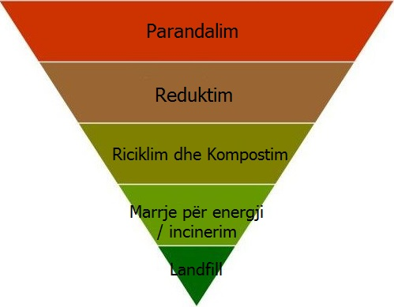
Since 2011, the Albanian Government works with the National Strategy and Plan of integrated waste management, which is expected to be reviewed in 2016, on the basis of administrative reform. The document describes how the policies will be implemented by the Government in partnership with the National Environment Agency (NEA), the Environmental Inspectorate (EI), local government units and other stakeholders, how short-term objective of the Government for recycling and composting of a quarter of municipal waste will be met, and how it will go beyond that.
The aim is to offer an integrated system of waste management, that starting from 2025 will recycle or realize compost in more than half of the waste landfill (deposit in landfills) to less than a third and gain energy from the remainder.

Fig. 3.1
- There is a hierarchy of waste management
- Albania approves EU waste hierarchy and is working towards EU policy of "0" emissions.
- Therefore investments should consider all stages of the hierarchy in order to invest properly for 12 landfill-sites and to ensure the financial sustainability of the scheme.

- Programs and the potential for waste reduction

- What does represent the concept of waste minimization
Minimization of waste represents general approaches, methods, activities and processes, aimed at reducing the volume of wastes destined for final treatment. As recommended by all strategic documents and EU directives, waste management should take into consideration the following options, ranging from more preferred to the one that is less:

- Waste Prevention: To ensure the conservation of nature and conservation of natural resources, waste generation should be minimized as much and whenever possible to avoid their production at source, or otherwise called "reduction at source" of waste;

- Re-use: Direct re- use of products / waste materials for the same purpose and nature of the initial use. - If the waste can not be prevented, materials or their products must be re-used directly, or upgraded / renewed with the aim of their reuse;

- Recycling / composting: When waste can not be prevented or re-used, they should be recycled or re-processed into a form that can be used as second-hand material for a purpose other than the initial use.

- The objectives to be achieved at the municipal level
- To identify waste reduction opportunities in the LGU;
- To identify opportunities to reduce the cost of collection and treatment of waste in the LGU;
- To identify opportunities to develop composting process in the LGU, and appropriate use of composting technologies;
- To define rules your LGU around responsibilities of producers and operators of solid waste management, construction and destruction;
- To plan a recycling program and discuss the elements of this program;
- To identify the main components of recycling within the rrymës municipal waste, how and why are used;
- To discuss technical solutions for the management of inert waste from constructions and demolitions as well as involvement of and involvement of recycling industry.

- Policies and rules of composting

Developing Policies and regulations, both at national and local level, are important elements for encouraging, and development activities for composting, as well as to further improve and modernize the performance of composting, especially in rural and suburban areas. LGUs can integrate and define their local regulations rules and sanctions, especially for organic waste and their management, which may favor the composting activities at rural level, as follows:
- Rules for allowing or preventing the dumping of waste: as p.sh, only organic waste from households / small kitchen and small businesses are allowed / should dump in urban containers, while organic waste from agriculture are prohibited to be dumped in these containers or on the road, as they should be treated by the owners (producers) with their means and costs. Organic wastes from gardens (herb, wooden branches, etc) are prohibited to be dumped on these konteiners or on the road; they should be gathered by their owners for composting in their gardens or sending with their means and costs into the landfill.
- Financing of incentives and sanctions: LGU can encourage the development of composting activities by financially supporting (grants, co schemes), or by adopting favorable fiscal policies for waste management, setting new tariffs or categorized the existing system of waste tariffs and other taxes, or by setting specific fines, p.sh, in case of an improper management of organic waste or illegal deposits in public spaces.;
- Efforts for education, communication and awareness campaigns to promote home and community composting, ranging from major producers and finishing to residents. At the same time these campaigns should encourage the separation of waste which is essential for the functioning of local composting plant.

- Composting, technology and its types

  - Process of composting
Compost is the product of a controlled aerobic decomposition of organic matter that requires oxygen. During composting, microorganisms consume oxygen (O2) by feeding on organic matter (Figure 4.1). Active Composting produces significant amounts heat, while in the air released large quantities of carbon dioxide (CO2) and water vapor.CO2 and water losses that are accounted for half of the original weight of the material. Thus, composting reduces the volume and mass of raw material, while the converts those into nourishing soil.
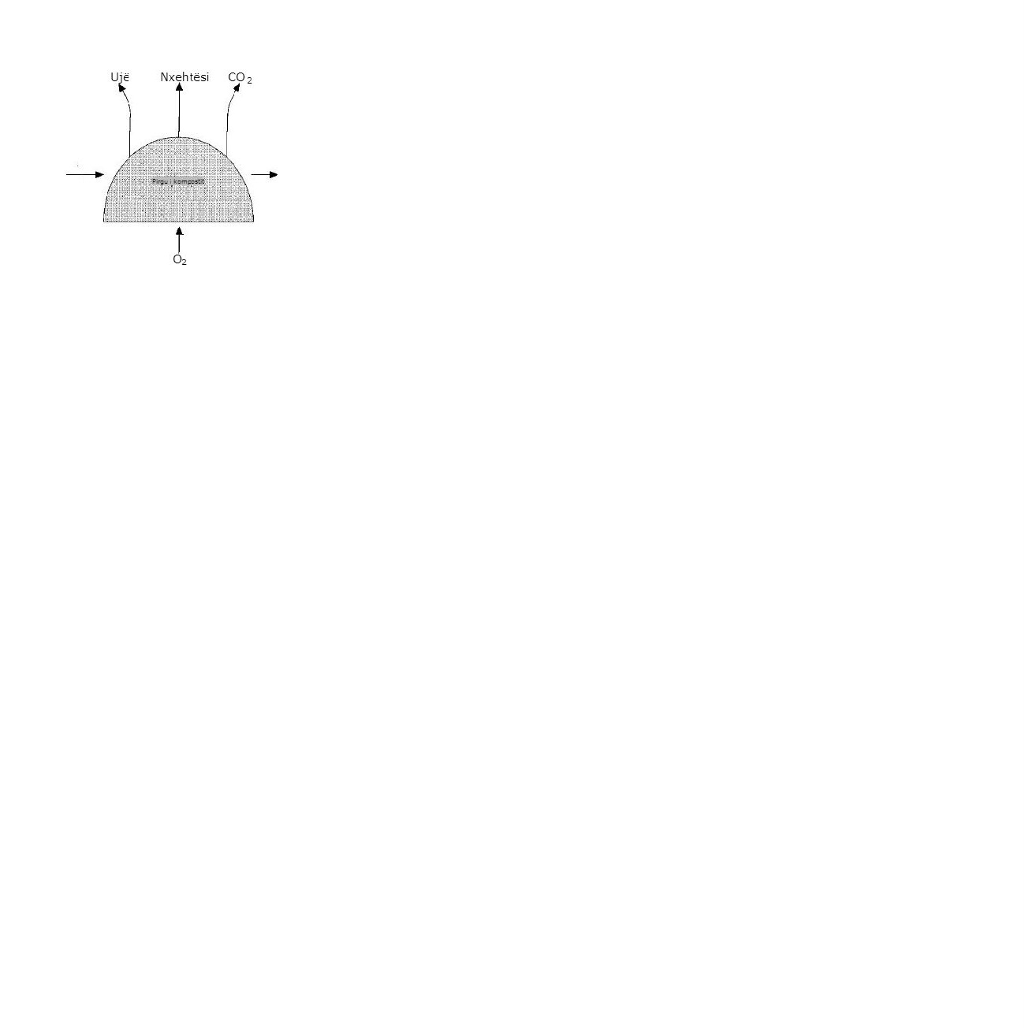
Organic substances (including carbon, chemical energy, protein, nitrogen)
Organic substances (including carbon, chemical energy, protein, mold); minerals; water; microorganisms
Minerals (including nitrogen and other nutrients)
Water

microorganism

Raw material Composting completed
The amount of carbon, chemical energy, protein and water in the finished compost is less than the amount in the raw material. Composting has completed more humus. The volume of finished compost is 50 or less than the volume of raw material.

Fig. 4.1
The process of composting

Composting is faster when accessed and stored conditions that encourage the growth of microorganisms (Table 4.1). The most important conditions include:

- Organic materials are properly mixed to provide the necessary nutrients for growth and microbial activity, including a balanced supply of carbon and nitrogen (ratio C: N).
- Oxygen is at levels that helps aerobic organisms.There is enough moisture to allow the biological activity without hindering ventilation.
- Temperatures encourage a vigorous microbial activity of microorganisms’ termofilike.

Table 4.1
Conditions recommended for rapid composting
Conditions | Accpetable limits | Preferable limits
carbon - nitrogen Ratio(C:N) | 20:1 – 40:1 | 25:1 – 30:1
Moisture | 40 – 65%^{b} | 50 – 60%
Concentration of oxygen | Greater than 5% | Much greater than 5%
The dimensions of the particles (diameter in cm) | 0.32 – 1.27 | Vary^{b}
pH | 5.5-9.0 | 6.5-8.0
Temperature (ºC) | 43 – 65 | 54 – 60
a These recommendations are for rapid composting. However, the conditions outside these borders can give successful results.
b Depends on specific materials, dimensions of the pile and / or weather conditions.
    - What happens during composting
Composting begins just huddle together appropriate materials. The initial mixture of raw materials brings enough air to start the process. Almost immediately, mikororganisms consume oxygen and exhale air base materials out through pores. By reducing the amount of oxygen, aerobic decomposition slow down and may even be interrupted if not re-filled oxygen. Ventilation is required continuously, to perform the re-supply of oxygen. Ensure ventilation or air through passive sharing (natural circulation and diffusion) or through forced ventilation (blower / fan). Mechanical shock composting materials, or mixture, bring a limited amount of oxygen, but this amount is consumed quickly and must be filled through passive motion or forced air. Mixture should be made to have a well ventilated. It recreates the pores within the heap, so that air moves more easily through materials (Fig. 4.2).

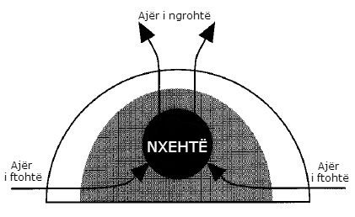

Fig. 4.2
Natural movement (passive) air in a pallet stack or composting

Since the release of heat is directly related to microbial activity, temperature is a good indicator of the process. Temperature increases resulting from microbial activity observed within hours after the formation of the heap or pallets, as they are consumed easily degradable components, such as sugars. Temperatures composted materials that undergo a rapid increase up to 50-60 ° C, which is stored for several weeks. With the slowdown of active composting temperatures gradually decreased over 38 ° C and finally fall to ambient temperature value

During active composting, the temperature falls if oxygen is lessened because the microbial activity falls. Temperature rise again after mixing or forced areation. If available oxygen and microbial activity is intense, the temperature can rise well above 60°C. At this point, many microorganisms begin to die or reduce life activity. Then, the reduction of microbial activity, temperature may stabilize or even lower. Updating the heap through mixing or forced ventilation helps hold temperature away these harmful levels.

Usually, the period of active composting is followed by periods of conservation. During conservation, the materials continue to be composted, but with a much lower rythem. The level of oxygen consumption decreases to the point where compost can be collected without the need for mixing or forced aeration.
There is no certain point where the process of composting it ceases. Materials continuo to be broken down until last feeders are consumed by recent organisms that remain and while almost all the carbon is converted to carbon dioxide. However, compost becomes relatively stable and usable, long before this point. Composting deemed has become' launch of the features associated with the use and treatment, such as the ratio C: N, the demand for oxygen, temperature and aroma. Composting is judged that "has become" based on the features associated with its use and handling, such as the ratio C: N, the demand for oxygen, temperature and odors.

    - Factors affecting the composting process

Factors affecting the composting process include oxygen and aeration; feeders (ratio C: N); humidity; porosity, structure and size of the particles; pH; temperature; and time

Oxygen and Aeration
Aerobic composting consumes large quantities of oxygen. During the first days of composting, raw material components that are ready for degradation are metabolized soon. Hence the needs for oxygen and heat production are higher in the early stages and then fall with aging process. If the supply with oxygen is limited, the composting process is slow down. It is needed a minimum concentration of oxygen of 5 % within the pore spaces of the compost heap (air has about 21% oxygen).
Without sufficient oxygen, the materials become anaerobic. Anaerobic decomposition involves different set microorganisms and various biochemical reactions. Generally, anaerobic processes are considered to be slow and less effective than aerobic processes. It produces less heat to evaporate water from the materials. Anaerobic processes form substances such as methane, organic acids, hydrogen sulphide, and other substances. Many of them have strong odors, and some have even security concerns. Although, the intermediate components (such as organic acids) are formed during aerobic decomposition, they continue to decompose when no oxygen is available. In anaerobic conditions, these compounds accumulate. An adequate oxygen supply provides effective aerobic organisms competitive advantages compare to anaerobic organisms. Maintaining aerobic conditions is important for avoiding bad odors associated with anaerobic decomposition.

Besides providing oxygen, aeration removes heat, water vapor and other gases that are found within the composting materials. In fact, the level of ventilation required for removal of heat can be ten times higher than that required to provide oxygen.Thus, the temperature often determines to what extent and how often ventilation is required. The level of ventilation required to reduce the amount of humidity, normally, is higher than that required to provide oxygen, but lower than the level for the removal of heat.

Nutritions (ratio C: N)
Carbon (C), nitrogen (N), phosphorus (P) and potassium (K) are the primary nutrients required by the microorganisms involved in composting. Nitrogen, phosphorus and potassium are the primary nutrients for plants too; so that their concentrations also affect the value of compost.

Many organic materials, including livestock manure, plant residues and food, contain abundant amounts of nutrients. It seems that the composting process is influenced by the amount of excessive or inadequate carbon and nitrogen. Organisms use carbon for energy and growth, while nitrogen is essential for protein and reproduction. In general, biological organisms, including man, need about 20 times more carbon than nitrogen. So, it is important to ensure carbon and nitrogen in the relevant reports. Carbon to nitrogen ratio refers to the ratio C: N. Usually, a balanced ratio of C: N ensures that even the appropriate other nutrients are present in sufficient quantities.

Although the ratio C: N is a useful guide for the formation of the mixture of compost, it must be considered the rythem at which decompose the carbon components. For example, straw decompose and releases carbon to the germs more easily than wood materials. This is because the composition of carbon in wood case relates to a large extent by lignits, organic ingredients that are more resistant to biological disintegration. On the other hand, simple carbon to carbohydrates or to fruits waste it is consumed more quickly than carbon cellulose to straw.

Humidity
The humidity is necessary to support the metabolic processes of microbes. Water provides the means for chemical reactions, transports nutrients, and allows the microorganisms to move. In theory, the biological activity is optimal when materials are saturated. He fully terminates under a moisture content of 15%. However, in practice, the composting materials must be held within a much narrower range of moisture content, generally between 40% and 65%.
Experience has shown that the composting process is inhibited when the moisture content is approaching to 40%. Below 40%, microbial activity continues more slowly. On humidity levels above 65%, the water moved a large part of the air in the pore spaces of composting materials. This restricts air movement and leads to anaerobic conditions.

As the moisture content, generally, lower over the course of composting, the initial moisture content should be sufficient over 40%. For many mix compost, materials that are very dry are mixed withy materials that are too wet to achieve a moisture content of 50-60%. For some dry materials, such as leaves, sometimes water can be added directly.

A moisture content of 40-65% is a general recommendation that works well for all materials. In fact, the maximum acceptable level of moisture depends on the porosity and absorption ability of raw materials. More porous materials may be wet than densely packed materials. When we have a mix of more absorbing material, it needs to maintain a humidity level greater than 40% to assist in rapid composting.

Porosity, structure, and size of the particles
Porosity and structure relates to physical features of materials, such as particle size, shape and their density. They affect the composting process through the influence they have on ventilation. They can be adjusted through the selection of raw materials, as well as through grinding or mixing. Materials that are added to adjust these features referred to additions or zoom agents.
Porosity is the amount of air space within the compost and determines the resistance to air flow. It is determined by the size of the particles, the gradual change of materials dimensions and continuity of air space. Larger particles and uniform increase the porosity.
Structure refers to the hardness of the particles - that means their ability to resist sedimentation and compression. A good structure prevents the loss of porosity in the humid environment of the compost pile.
As the surface area increases with decreasing of particles size, the level of aerobic degradation increases when we have particles with smaller size - which means, within the limits. But, on the other hand, smaller particles reduce the effective porosity, so a compromise is needed. Usually, the best results are achieved when the particles are of average diameter of 0.3 cm to 5 cm.
For most elements of raw materials and composting activities, it is achieved an acceptable porosity and structure if the moisture content is below 65%. However, in some situations it can be benefited from special attention dedicated to the porosity and structure. Composting methods that do not involve mixing, requires more structuring, to resist sedimentation, so that larger particles are needed. Strong aroma materials can be mixed with solid material to have porosity greater than normal, in order to encourage air movement.

pH of the material
The composting process is relatively insensitive to pH, within the limits that are commonly found in mixtures of organic materials. This, to a large extent, is due to the broad spectrum of microorganisms involved in the process. The preferred pH is at 6.5-8.0 borders, but the natural buffer capacity of the process makes it possible to work in a much wider range. Composting can effectively proceed with pH levels between 5.5 and 9. However, it seems that it is much less effective at 5.5 or 9 than when the pH is close to neutral (pH = 7).
pH becomes important for materials of raw materials that have a high percentage of nitrogen. A high pH, over 8.5, encourages the conversion of nitrogen into ammonia compounds, which increases alkalinity. The adjustment of pH decreasing to fewer than 8.0 reduces ammonia losses. Adjusting the pH to increase by adding lime, ash, or other additives is usually not necessary, and often not recommended because of potential effects on ammonia losses. If these additives are used, they should be used in small quantities and should be well mixed with other materials.
Composting changes materials and their pH as decomposition occurs. For example, the liberation of organic acids can temporarily lower the pH during the early stages of composting, while the production of ammonia from nitrogen-containing ingredients can increase pH. Regardless of pH of the initial materials, composting gives a final product pH stabilized, which has a value near neutrales (7).

Temperature
Basically, composting is accomplished within two temperature ranges known as mezofilik (10-38°C) and termofilik (over 40°C). Although mezofilike temperatures allow effective composting, most experts suggest maintaining temperatures between 43°C and 65°C. Termofilike temperatures are desirable because they destroy more pathogens, weed seeds and larvae of flies in the composting materials.
Microbial decomposition during composting, releases large amounts of energy in form of heat. Features self - insulation of composting materials lead to the accumulation of heat, which increases temperature. At the same time, material constantly loses heat with water vapor and air stream which removes water vapor and other warm gases. Mixing and ventilation speed the heat loss, so they are used to maintain proper temperatures within limits. Cold weather and little piles increase heat loss.
Accumulation of heat could increase enough temperature over 60°C. When this happens, the germs begin to suffer the effects of high temperature and slow down the composting process. The temperature may continue to rise over 71°C due to the heat generated by continuous microbial activity and insulation characteristics of composting materials. At this point, many organisms die or become inactive. Effectively, the process stops and does not resume until the population of microorganisms recovered. To prevent this situation, temperatures should be monitored. When temperature is approaching 60°C, it has to accelerate the loss of heat through forced ventilation or mixing of materials.
As the majority of the loss of heat during composting happens from the evaporation of water, the materials should not be allowed to be dry below 40% moisture content. Low humidity increases the chance to measure harmful high temperatures, as well as spontaneous oxidation.

Time
Time is required to transform raw materials into compost depends on many factors, including materials used, temperature, humidity, ventilation frequency, and user requirements. The right moisture content of thehumidity and proper ratio of C: N plus frequent ventilation, ensure the shortest time possible for composting. Conditions which slow down the process include the lack of humidity, a high ratio of C: N, low temperatures, inadequate ventilation, large particles and a high percentage of resistant materials (such as wood).

Appropriate period of composting depends on the purpose of the use of compost. The period can be shortened if the compost does not need to be completely stabilized. For example, if the compost will be used in a field of wheat well before the growth season, it can be preserved and be completed in the field. Often composting period’s extendes when compost is required to be particularly dry or mature.
In general, in favorable conditions, decomposition and storage of all materials can be achieved within a few weeks, but the most common is a period greater than two months. Although some highly controlled mechanical systems claim less than a week to produce compost, usually it recommends a conservation period of four to eight weeks before the compost is used. In Table 2.2 are given typical composting periods for some common activities.
A particular process can achieve stabilization through quickly drying materials to a moisture content, which inhibits the biological activity. This is fine if the final use of compost does not dictate a more complete stabilization. However, partly mature compost is not suitable for use in horticulture. Also, it is important to know that, when dried materials regain moisture, the biological activity resumes. Then the problems of odors and other problems are shown, if sufficient ventilation is not provided.

Tab. 4.2
Typical composting periods for selected combinations of methods and materials
Methods | Materials | Active Period of Composting |  | Conservation Period
Methods | Materials | Limits | Typical | Conservation Period
Composting passive | Leaf  Manure mixed with straw | 2-3 years  6 months to 2 years | 2 years  1 year | -  -
Pallets - rare mixture | Leaf  Fertilizer + extras | 6 months to 1 year  4-8 months | 9 months  6 months | 4 months  1-2 months
Pallets - mixture of frequent | Fertilizer + extras | 1-4 months | 2 months | 1-2 months
Airy palette passive | Fertilizer + straw  Fishes + peat | 10-12 weeks  8-10 weeks | -  - | 1-2 months  1-2 months
Airy Static pile | Sludge + wood chips | 3-5 weeks | 4 weeks | 1-2 months

    - Changes of materials during composting
During composting, microorganisms transform organic raw material in the compost by breaking down the components of simple materials and reunited them into new compound complex The conversion changes the nature of the materials. The raw material begins as a diverse mixture of particles and compounds, most of which are easily degradable and potentially aromatic. In the moment composting is completed, the mixture of compounds made with uniform and less active biological standpoint. It is observed little or no trace of the raw material stage. The material takes a dark brown to black. Particles reduced in size, are established and have a structure like the earth.
During the process, the amount of humus increases, the ratio C: N decreases, pH neutralized, and the exchange of material capacity increase.

Composting leads to the decrease of the initial volume with a quarter to more than half of it, depending on the materials of the raw material. Typical agricultural materials demonstrate a greater contraction in volume. A part of this volume was waning represents the loss of CO2 and water in the atmosphere. Also, composting materials undergo a greater reduction in weight, 40-80 level, mainly due to loss of water
There is also a certain loss of nitrogen as a result of the removal of ammonia from the compost heap. However, composting saves all nutrients that are supplied from the raw material, and stores them within sustainable organic ingredients. This reduces the immediate availability of nutrients for plants, but allows you to shake feeders with a gradual rythem.

Report C: N diminishes gradually during composting, due to loss of CO2, the initial materials. The amount of carbon lost during composting, usually exceeds the amount of nitrogen lost. However, if the initial ratio C: N is low, less than 15: 1, nitrogen losses can be sufficiently high to cause a small change to report C: N ..

Transformations that occur during composting require energy. Organic materials used for composting containing a significant amount of energy deposited. Deposited energy is resulting from solar energy conversion to chemical energy during photosynthesis. Having dissolved chemical bonds of organic materials, micro-organisms obtain energy for growth. During the process, a part of the chemical energy is converted into heat, which increases the temperature of the heap and leave in the surrounding area.

Microorganisms dekompose organic materials progressively, by cracking them from complex substances in intermediate and then simple. The nutrients that become available during the decomposition remain to compost within young body’s microorganisms and humus. The final product has a rate lower microbial activity, but is rich in microorganisms and microbial residues.
Some organic compounds, which are present from the beginning to the raw material, pass through the composting process by undergone little or no changes. For example, lignits was found in timber, itemized with difficulties within the typical period of composting. Lignits and other substances resistant to biological standpoint focus to compost. They are partly responsible for the characteristic qualities of compost.

    - Conservation
Conservation is a critical phase, but often is neglected, during which the compost matures. Conservation occurs at low temperatures, mezofilike. Oxygen consumption, production of heat and evaporation of moisture are at much lower levels compared with active composting phase.
The importance of conservation increases if active composting phase shortened or poorly managed. A long period of conservation guarantees a security feature that helps in overcoming the shortcomings of the method of composting and also reduces the possibility of using matured compost. Composting prematurely continues to consume oxygen lessening the availability of oxygen to plant roots. On the other hand, prematured compost may also contain high levels of acids, a high ratio of C: N, and other features which are damaging if the compost is used for some aktivietete in horticulture.
Conservation enhances aerobic decomposition of constituent’s resistant, organic acids, large particles and clusters of material remaining after active composting. As a result, the pH goes into neutral, the ratio C: N decrease, exchange capacity increases and the concentration of humus increases. Some changes that were visible only occur at low temperatures, or well decomposed organic matter (which is not present during active composting).
Because the conservation continues aerobic decomposition process, it requires sufficient natural ventilation. That limits the size of the piles of conservation and moisture content in them. Compost heap becomes anaerobic within conservation has some harmful qualities similar to those found in compost of prematurely.
There is a specific moment when conservation should start or runs. When the temperature of pallets does not re-emerge after mixing, the conservation phase begins. When used forced ventilation, conservation begins when the temperature of the heap shown a steady decline and approaching levels mezofilike (eg 40 ° C). Conservation can be considered finished when the heap temperature falls to ambient temperature (where the pile is not anaerobic or too dry). As a general rule, it is recommended that the minimum time to be conserved is one month. But, again, it is needed a longer time, if active composting is not finished.

  - Materials for composting
Materials that are composted are very important. Also microbes that disintegrate in compost are important for plant health. Composting needs rich material in cellulose, carbon and nitrogen. In this regard use of kitchen waste for composting takes a major importance.

Materials of compost component are divided in to two main categories:
- brown have carbon content and include leaves, mud / dust, grocery bags, bird seed husk, chips wood, etc;
- green have nitrogen content and include clippings grass, clippings plant, animal manure, food waste etc.
The ideal mixture is 75% content of "brown" and 25% of "green" in terms of volume. If the mixture is carried out under the weight it should be in the ratio 50/50 between materials rich with nitrogen and carbon. For example, in one kilogram of kitchen waste, it is best to have a kilo of leaves.
If your compost is too wet, add more brown material. If you do not have enough green material it can be added water to compost. Keep in mind that brown and green materials do not refer to the color of the material, but is a form of separation of materials rich in nitrogen and carbon.

    - What to compost and what not?
Table 4.3 shows the materials / products that should not be composted, Table 4.4 with materials that can be composted with caution and skills and Table 4.5 with composted materials.

Table 4.3: Things you should NOT compost!
Materials | Carbon/ Nitrogen | Details
Ashes (coal or charcoal) | n/a | May contain materials that are toxic to plants.
Cat droppings/litter | n/a | These may contain disease organisms and should always be avoided for composting.
Colored paper |  | It can contain toxic materials for the plants
Lime | n/a | High alkaline pH can kill composting action.
Meat, fat, grease, oils, bones | n/a | Do not break down, can coat materials and “preserve” them, can attract pests.
Nonbiodegradable materials |  | They are not dissolved and reduce the quality of compost
Toxic materials |  | They can prevent the process of composting and produce compost with toxid content

Table 4.4: Things that MAY be composted, but only with caution and skill
Materials | Carbon/Nitrogen | Details
Bird droppings | Nitrogen | Some bird droppings may contain disease or weed seeds
Diseased Plants | Nitrogen | Make sure your pile gets to at least 135 degrees Fahrenheit for a few days to let it “therma kill” the disease
Milk, yogurt, cheese | Neutral | May attract pests, so put it in the middle to deep into the pile
Weeds | Nitrogen | For best results, dry them out until crunchy, then add them to your compost pile

Table 4.5: Things that can be composted - YES!
Materials | Carbon/Nitrogen | Details
Alfalfa meal and hay | Carbon | Shredding or chopping it up will help it break down quicker
Algae, seaweed and lake moss | Nitrogen | Good source of nutrients and minerals.
Apple pomace (cider press waste) | Nitrogen | If dried use as a carbon
Ashes (wood, not coal) | Neutral | Use only wood ashes since coal ashes can be toxic to plants. Use sparingly as a pest deterant.
Banana peels | Nitrogen | Shredding or chopping it up will help it break down quicker
Beverages, kitchen rinse water | Neutral | Help keep the pile moist, but don’t over do it.
Buckwheat straw or hulls | Carbon | Shredding or chopping it up will help it break down quicker
Cardboard | Carbon | If you have lots of this, consider recycling it. Otherwise, shred into small pieces in pile.
Coffee grounds (and filters) | Nitrogen | Great source of nitrogen and worms love coffee grounds! The filter will break down so add it too!
Cornstalks, corn cobs | Carbon | A little tricky, so shred and/or break down and mix well into pile.
Dryer lint | Carbon | Yum, lint. Make sure you moisten it a little before you add it.
Egg shells | Neutral | These break down slowly, so make sure to crush these before adding.
Feathers | Nitrogen | Slow to break down, shred if possible to speed up process
Flowers | Nitrogen | Green use as Nitrogen, dried use as carbon
Grape pomace (winery waste) | Carbon | When dried and shredded best used as a carbon
Green Grass clippings | Nitrogen | When green can be used as a Nitrogen
Dried Grass clippings | Carbon | Make sure they are not too wet and mix with dry leaves for best results.
Hair | Nitrogen | Good source of nitrogen. Make sure you scatter, so it doesn’t clump.
Hay | Nitrogen | The best kind is hay that is not suitable for livestock and is starting to decay on its own. Make sure it is dry and weathered.
Hedge Clippings | Carbon | Shredding or chopping it up will help it break down quicker
Hops (brewery waste) | Carbon | When dried and shredded best used as a carbon
Kelp (seaweed) | Carbon | Good source of potassium (perfect for growing potatoes!). Use sparingly or sprinkle kelp meal in to get your pile cooking.
Leather (leather waste) | Nitrogen | Shredding or chopping it up will help it break down quicker
Leaves | Carbon | Shredding or chopping it up will help it break down quicker
Manure from herbivores (cow, horse, pig, sheep, chicken, rabbit) | Nitrogen | Best if known to come from a herbivore
Newspaper | Carbon | Shredding or chopping will help it break down quicker
Nut shells | Carbon | Shredding or chopping will help it break down quicker
Oak leaves | Carbon | Shredding or chopping will help it break down quicker
Sawdust and wood shavings | Carbon | Preferably not from kiln-dried wood
Paper | Carbon | Shredding will help it break down quicker
Peanut hulls | Carbon | Shredding or chopping will help it break down quicker
Pine needles and cones | Carbon | Shredding or chopping will help it break down quicker
Tea leaves | Carbon | Best if shredded to help it break down quicker
Vegetable peels and scraps | Nitrogen | Kitchen scraps are a great source of nitrogen
Weeds | Carbon | Don’t add if your concerned about spreading the seeds
Wheat straw | Carbon | Best if shredded to help it break down quicker

Equipment for compost
In many of composting operations it is observed the need for devices which serve to regular maintenance needed to compost during the decomposition of organic material. There is a range of equipment needed in the process of decomposition. Such are:
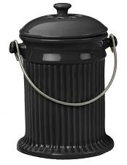
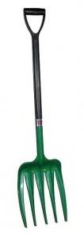
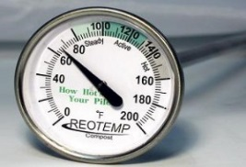
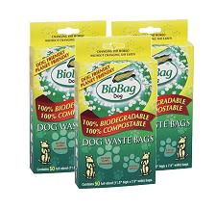
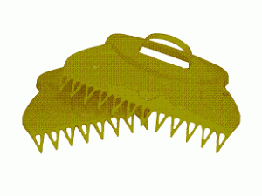
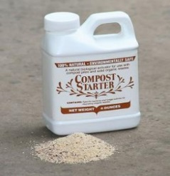
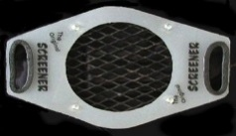
Waste bins are essential when it comes to composting. Typically, they are small
baskets that can be made of chrome or ceramic, which stand in the kitchen.

Pitchfork is a means for gathering and the return of a group of waste. In some cases they also serve as aerators for a pile of waste.

Composting thermometer is used to ensure that the pile of waste will always be at the right temperature to return to a good organic material.

Bags / bio bags are a phenomenal way to dispose waste, or for use in your compost when it comes to home composting. They are completely biodegradable.

Leaf collection tools - help to blend large amounts of waste. Leaves are excellent material containing carbon and balance waste quantities with high nitrogen level (such as food scraps).

Compost activator is usually a natural substance that activates the piles of garbage and organic solid waste and helps to accelerate the time of decomposition and digestion of organic waste. Compost activator helps in speeding up the time, the dissolution of the solid waste and maintains the pH balance.
Composting sieves are a good tool for garden waste collection and separation of waste for composting from the rest of the land.

Figura 4.3

Other auxiliary equipments for composting are:

- Machines with trailer
- Cutter
- Milling
- Shredding
- Waste container
- Other small materials (shovels, pickle, pickaxe, etc.)
- Materials for measurement of compost (pH, humidity, etc.)

  - Methods/Types of composting

Animal manure and other organic residues contain microorganisms that are capable of decomposing materials in anaerobic or aerobic way. Now it is clear that maintaining the presence of oxygen in the amount of compost is not only desirable but also necessary to have a rapid composting. Composting method shows how to achieve this. Method also gives info on other factors affecting the process, such as temperature control, movement of materials and control of odors.

Despite the fact that composting has been used for years, especially by farmers, techniques or ways used for composting are scarce and non-standardized. Often new methods are piloted, Innovative which try to adapt to different environments like schools, major service centers, institutions etc.
However, for our focus, we will explain the basic techniques applicable in the case of rural areas.

- Passive composting manure
- Activ composting applying:
- Pallets
- Decomposition of ventilated place (individual)
- Decomposition of ventilated place (three - four fold)

    - Passive composting of manure piles
Simply by placing manure in pile does not begin to satisfy the requirements for continuous aerobic composting. Self manure is rich in nitrogen and poorest in carbon. He has passed through the digestive apparatus of animals and is now more attractive to microorganisms.

Without a substantial material as bedding, moisture content at manure exceeds the level which allows the presence of an open and porous structure of the heap. Very few, or not at all, air passes through it. In these conditions, anaerobic microorganisms dominate degradation which inevitably happens. Also, it happens all of the adverse effects associated with anaerobic degradation, including low temperature, slow decomposition and release of hydrogen sulphide and other substances with bad odors.
As the water in the stack neither is removed from the air, or evaporates from high temperatures, the pile remains wet and anaerobic. These conditions combined produce likate salts, which comprise partially degraded organic substances. If the pile does not bullied, a crust it is formed in the surface. Then, when the crust split apart, odors that were within the pile go out.
When a livestock management system relies on bedding to help comfort and cleanliness of cattle, straw is mixed with manure and creates a mixture of dry and porous. This provides a certain structure and, depending on the quantity of straw, allows the mixture to pile in real heaps. Straw also tends to increase the ratio C: N in manure. If the pile of manure and straw is not very large, it can start composted. A large portion of the heap still can decompose in anaerobic manner, but, at least aerobic process is working in certain parts of the heap to remove moisture and to further break down anaerobic decomposition products.

These types manure will not be successfully composted if they are not in the right size and properly managed. Proper management includes ensuring that the mixture is sufficiently porous to allow air to penetrate, and mixture periodically, so that the pile recreate its porosity. Also, the pile must be small enough to allow passive air movement, generally less than 2 meters high and 4 m wide.

In essence, this passive method of composting, is composting in the palette, but with a much rarer graphic mixture. This is a common method that is used for composting of leaves. It is required a minimum of manpower and equipment. Passive composting is slow due to the low rate of ventilation, so the potential for having problems with odors is higher.

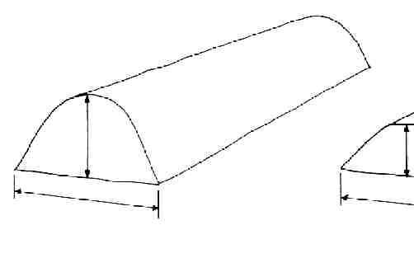
    - Composting in the palette
In this technical composting, compostable material is placed in parallel lines separated by considerable space. Pallets are usually made in space uncovered and are based on the combination of natural ventilation with mechanical mixing to ensure aerobic conditions.

Fig.4.4
Advantages:
- easy to realize ;
- treat a significant amount of organic matter;
- There is no need for experience.

Disadvantages:
- requires large space;
- In cold weather needs coverage to maintain temperature;
- can produce bad smell

    - Composting in the country-decomposition of ventilated (individual)
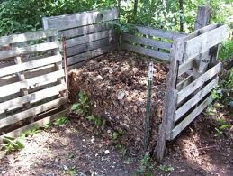
We have similar technique which may be adopted in almost every yard, compostable materials dried and fresh (preferably placed in layers or mixed well) in the process of decomposition left for about 1 month and then begin the process of mixing to enable ventilation.

Fig. 4.5

Advantages:
- very easy to be realized in house conditions or in the field;
- There is no need of mixing machinery equipment or costly equipment;
- There is no need for experience.

Disadvantages:
- limited quantity to be treated ;
- mixture must be done by hand.

    - Composting in landfills airy (the three-quadruple)
This technique is similar to the above technique, only increase the number of compost heaps ventilated in order to facilitate and improve the process of motion and ventilation. In this technique once a barn is filled first and the movement of material in the second compost heaps, the first pile is ready to start a new filling.

Advantages:
- easy to be carried in conditions of farm plot, field
- needs no mixing machinery equipment or costly equipment;
- There is no need for experience;
- offers the possibility of treating a considerable amount of organic matter and continuously.

Disadvantages:
- no need to mix with labor (in the case of increasing the compost heaps, use of tools is available to eliminate this disadvantage)
- Can produce bad smell.

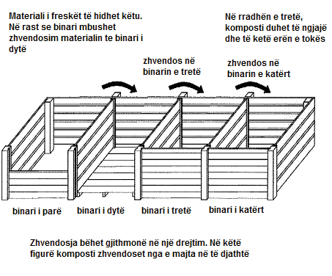

Fig 4.6

  - Technology of composting / activities associated with composting
Making compost is probably the single most important thing that you can make for your farm. Success depends on the land, and the health of your soil depends on the mixing of waste to produce compote.

Finding the right technology for organic waste composting depends on the availability of land, material volume, density of population, and regulatory constraints.

    - Deposit / storage and handling of raw materials
There are many approaches to make the compost, but the fastest way to get the compost ready is the creation of an active compost pile. Ensuring a steady supply of water and air in the pile, you would encourage microorganisms that stimulate composting process to work more quickly.
The decomposition is an essential and continuous process where organic materials or carbon-based exposed to the elements of nature, especially air and water, dissolved in lower organisms. Decomposition produces nutrient-rich foods that can easily evaporate from soil microbes serving as nutrients for plants. However, producing this high quality, the products require time and the right temperature.
Composting begins by collecting suitable organic materials that are then mixed to achieve the desired C:N ratio, moisture content, and pore space. Usually one material is the primary material, such as animal manure, and one or more amendments are added to it.

Initially, the materials must be collected and moved to the composting site. Usually amendments are stockpiled at the site, to be added to the manure or other primary material that is periodically brought to the site. A primary material like manure receives immediate attention because it can quickly become anaerobic, and emit undesirable odors when it is subsequently disturbed. Some materials, like cattle manure, may be stored for several days; but it is usually best to promptly handle the primary materials.

Amendments like straw, wood chips, leaves, and sawdust respond much more slowly to microbial activity because they have high carbon content and are usually dry. They can be stored for an appreciable length of time before they begin to degrade. If they become wet, they begin to compost but at a slow rate because of the lack of nitrogen. Some ingredients which are neither primary materials nor dry amendments, such as crab shells, may pose a potential odor problem. These must be brought to the site just prior to composting or handled in a manner that prevents odor problems (see odor control section).

Most amendments can be stockpiled outdoors without a cover. A roof helps to minimize the initial moisture content of the mix and reduces the possibility ofleaching nutrients from wet materials during storage. However, the trade-off in cost for the roof must be considered. Available space in existing farm buildings should be considered first. Most farm structures used for bulk storage should work well.

Trash is a potential problem with several off-farm materials, especially paper. Such materials need to be stored and handled in a way that keeps them contained within the storage area. Shredded paper and cardboard should be bailed and/or stored inside if not composted immediately. The manner in which all raw materials are stored and handled greatly influences the neighbors' and the community's acceptance of the composting operation.

Occasionally, raw materials need to be sorted or separated prior to composting. For example, horse stable waste may contain miscellaneous trash, or leaves may include plastic bags. The ideal solution to sorting materials obtained from off the farm is to convince the supplier to sort them before delivery. However, this is not always possible, or it may require some negotiation of fees charged. In most cases, foreign objects can first be removed by hand when the material is delivered, and then continuously throUghout the composting process. Turning and subsequent settling of piles and windrows tends to push both large and light objects to the surface of the pile, where they are noticeable and can be removed. For the rare case when raw materials contain a large amount of unwanted materials, mechanical separation is necessary (for example, screens and magnets).

    - Shreding
Shred materials as finely prior to mix them in batch. For example, you can shred the leaves by running trimmers on them. The same strategy applies to kitchen waste "as smaller, the better" is the rule for compost ingredients.

Most raw materials used for farm composting do not require grinding or shredding, especially if a windrow turner is employed. Several raw materials that benefit from shredding include newspaper, corrugated cardboard, brush, and other yard wastes. Tree stumps and other large objects cannot be composted without size reduction. Shredding also allows materials like newspaper to be used as bedding prior to composting. Noise and dust created by grinding/shredding are potential problems.

There are a variety of of commercial grinding and shredding equipment promoted for composting systems, including equipment used on farms for shredding hay bales and preparing feeds. Other possible equipment choices include paper shredders, large garden shredders, mowers, and forage choppers. Some size-reducing mechanisms can be matched with accessory equipment, such as balers, dust separators, conveyors, and screens. The actual capacity depends considerably on the materials, loading rates, and other specific conditions. Costs also vary a great deal with specific power requirements and accessory equipment. If a grinder or shredder is required for only several weeks a year, rental equipment should be considered.

    - Blending and formation of piles / Pallet
As your compost can be hot in the center of mass, outside cluster is fresh, giving organisms a chance to survive. Mixing brings fresh material in hot area and also increases ventilation which helps to achieve higher levels of heat.

The first essential step in the overall composting system is to mix the raw mate rials in the proper proportions and then form the mixture into a pile or windrow or load it into a vessel. With most in-vessel methods, the mixing step is built into the system. The materials need only to be loaded into a silo, hopper, or vessel using conventional materials handling equipment (conveyors, augers, and/or bucket loaders). The composting equipment does the rest. With the windrow and aerated pile methods, mixing and pile formation are distinct steps. For the aerated static pile system in particular, initial mixing is crucial. Mixing is performed once, and the quality of that mixing continues through the whole composting process. With the windrow system, the initial mixing must proportion the raw materials and blend them to some degree of consistency. Subsequent turnings mix the materials more thoroughly. Frequent turnings improve compost consistency and diminish the importance of the initial mixing.

Mixing and windrow/pile formation can be accomplished in several ways, depending on the composting method used, available equipment and labor, and the manure-handling practices of the farm. Loaders, manure spreaders, and other equipment already on the farm are usually adequate for mixing materials and forming windrows/piles. This is particulary true for windrow com posting. However, mixing and windrow/pile formation demand more labor than other composting operations. To reduce the labor involved or improve the performance, it may be advantageous to obtain new equipment or alter existing equipment for example, upgrade the manure spreader or purchase a larger bucket for the loader.
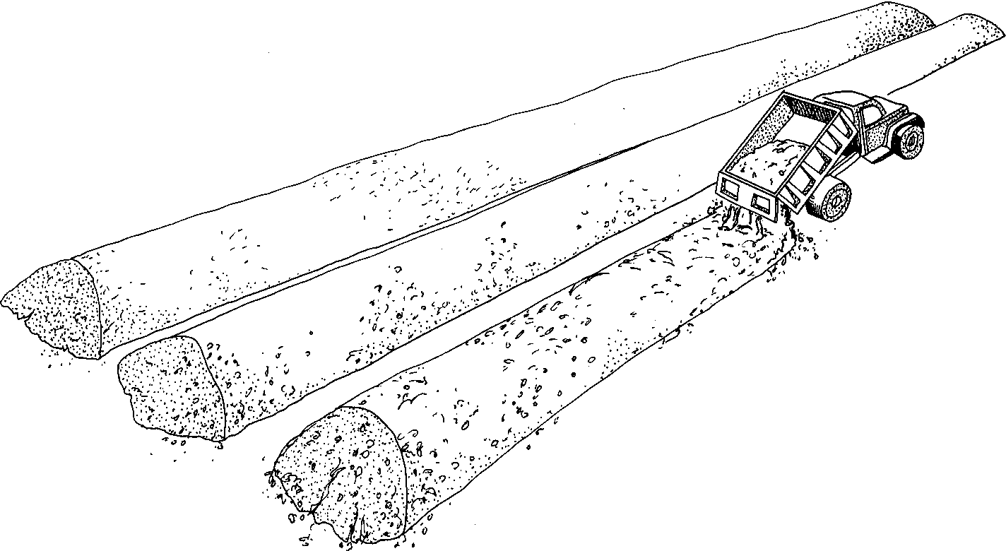
When the compost site is remote from the mixing area, dump trucks or wagons can transport the mix to the site and build the initial pile/windrow. The materials are unloaded by backing up to the end of the existing windrow and tilting the bed of the truck or wagon while slowly moving the vehicle forward. The speed and truck or wagon dimensions determine the windrow/pile heights. If necessary, a loader can reshape or enlarge the pile/ windrow formed.

Fig 4.7

To improve the initial mixing, the manure and amendments should be loaded in the spreader in alternate loads (for example, two buckets of manure, four buckets of amendment, two buckets of manure, four buckets of amendment, and so on). Locating the amendment storage near the source of manure reduces the labor involved in loading the spreader in this manner. Some materials pose problems for the typical spreader mechanism. For instance, long straw is more difficult to mix than chopped straw, so if equipment is available it is best to chop the straw.

Liquid ingredients pose special handling problems because they need to be incorporated into the composting mix without making it soggy. Also, many liquids present a potential odor problem. Examples of liquid raw materials include manure slurries, fish processing wastes, dairy wastes, and small volumes of wash water. These materials might be the primary waste or a secondary material that the composting system is able to absorb, or they may be added for their nitrogen value.
Occasionally, liquid is added to windrows that actually lack adequate moisture. This creates a good opportunity to dispose of certain dilute liquid wastes, like milk room wash water or site runoff collected in holding ponds. In any case, the other raw materials must be absorbent enough to hold the added liquid without sacrificing porosity. Usually large amounts of sawdust, peat moss, paper, or recycled compost are required.

If the volume of the liquid ingredient is small, it can be added during the initial mixing. However, where the amount of liquid to be composted would make the initial mix overly wet, the liquid must be added regularly to an existing windrow, pile, or vessel as it loses moisture. This can be done with liquid-manure handling equipment or a side-unloading manure spreader, or it can be sprayed out of tank trucks or wagons. Turning is necessary soon after the liquid is added to blend it into the windrow. To prevent liquid from running down the side, it may be necessary to create a channel at the peak of the windrow and deposit liquid in the channel.

When the liquid is odorous, it may be better to contain it within the windrow prior to turning. This has been successfully done with fish wastes by injecting it into the windrow with an apparatus mounted to the side of a tractor. In this case, a chisel plow creates a furrow in front of the hose which sprays in the liquid. A trailing disc then covers up the furrow. After the liquid is absorbed and begins to compost, the wind row is turned.

    - Conservation, storage and treatment of compost
Choice of location is important to the success of composting. Compost producers need to consider not only the type of soil, land and topography but also water resources, treatment, wind direction and distance from neighbors.
To minimize handling the composting site should be near manure. Even well-managed locations do not avoid characteristic smell thus the wind direction should be considered in selecting the location.
Storage depends on the duration compost will stand in the canned compost. In determining the location remembers to leave space to operate the equipment in the compost pile. Allow space for a visual barrier you may need.
Following active composting, compost requires a curing period of at least one month to finish the process and allow the compost to develop the desired characteristics for its intended use. Usually, curing is practiced as a separate step and in a different area from the active composting stage. This frees space on the composting pad for the active windrows and piles which are more intensively managed. However, curing can certainly take place in the same piles and location in which active composting occurred.

Since curing piles are undergoing slow decomposition, aerobic conditions still need to be maintained. Anaerobic, or sour, curing piles develop odors and compounds toxic to plants. Although turning and forced aeration is unnecessary, curing piles should be small enough to permit adequate natural air exchange. A maximum pile height of 25 cm is often suggested. However, if the compost is intended for high-quality uses, such as potting soil, it is safer to limit curing piles to 20 cm in height and 45-60 cm in width. Since the piles are not turned, they can be placed close together to conserve space.

Anaerobic conditions can also arise from excessive moisture or water that accumulates at the base of the pile. Curing compost does not generate enough heat to evaporate the moisture gained from heavy precipitation or runoff. The curing area should be well drained with surface runoff channeled away from the piles. The length of the piles should run parallel with the angle of compost surface.

The most effective method of correcting wet or anaerobic conditions in a pile of compost is to remix the pile contents and spread the compost in an open area. This introduces oxygen throughout the mass and allows the anaerobic compounds to decompose aerobically or evaporate. Restacking the compost, after one to two days of aeration, it will most likely cause the pile to reheat and actively compost for a short period. The pH will require several days to a week to adjust to its normal value.

The use and sale of compost are usually seasonal, with peak periods in the spring and fall. This creates the need for three to six months of storage for compost produced continuously.

Finished compost that has been properly com posted and cured has a low but still ongoing rate of microbial activity. Although storage piles can be larger than curing piles, anaerobic conditiom; remain a threat. The pile height and width are generally determined by the reach of bucket loaders, conveyors, or other equipment. However, the height of the storage piles should not exceed 35 cm. As the pile size increases, the risks of sour compost and spontaneous combustion increase.
If wet or anaerobic conditions develop in storage piles, the corrective measures recommended for curing piles should be followed. In general, it is a safe practice to restack the compost from large storage piles into smaller piles a few weeks prior to use or sale. This allows the stored compost to aerate naturally and dissipate phytotoxic compounds that may be present.

If the compost produced is to be applied to cropland, the curing and/or storage piles can be located near the approprjate fields, similar to a manure stack. Again, poorly drained sites and steep slopes should be avoided to minimize anaerobic conditions and the loss of compost and nutrients from surface runoff.

    - The screening
When compost has reached the temperature of the air it is considered mature and rise in screening area. When you are ready to screen compost pass into another machinery. Finely screening of compost it is delivered to an upper place for storage. Because of the plastic that comes from compost, we need to care about the cleanliness of the garden. The only way that we can keep clean compost is placing it in a closed environment until it is ready to be sold.

Screening separates materials of different sizes and/or shapes. In a composting system, screening serves one or more of the following purposes: removes a large number of unwanted objects from the raw materials including rocks, metal, bottles, and other trash; separates the portion of a raw material to be composted from the portion not to be composted; improves the quality of the compost for sale or use by removing unwanted objects, clumps of compost, and material that is not fully composted; and recovers bulking agent from the compost for reuse. When screening is used in farm composting systems, it is nearly always performed after composting either to improve compost quality or recover bulking agents. The primary exception is screening of manure to recover the solids for composting.

When choosing screens, the important characteristics to consider are the screen opening size, capacity, effectiveness, cost, and susceptibility to blinding. Blinding refers to the condition when the screen openings become blocked with material. Most screens include some provision to reduce blinding, like brushes, vibration, or bouncing balls. For screening compost, the screen openings should be 0,63 to 1,27 cm, depending upon the material to be separated out and the end use for the compost. Smaller openings provide better separation but, for a given screen, reduce the capacity of the screen and increase the chances of blinding. Screen effectiveness relate to the success of separating the particles into the desired fractions. The effectiveness decreases when particles larger than desired pass through the screen or when particles of the desired size are retained by the screen. If the compost is to be old, the priority should be placed on keeping the large patticles from passing through the screen. Both effectiveness and capacity are influenced by the material feed rate as well as the screen opening size.

Screens perform better with dryer material. Usually, it is preferable to screen material after curing or drying. To screen compost without excessive blinding and lumping of material, the moisture content should generally be less than 50% and preferably less than 45%. In practice, the maximum moisture content depends on the specific screen used.
Some screen models have built-in shredding and mixing mechanisms or these can be added as an option. Such shredders include abrasive belts or hammers which break up clumps of material prior to screening. The mixers can add fertilizer or blend together sand and compost to produce topsoil.
Many different types of screens are available. Screens commonly used to separate compost and other soil-like materials.

    - Drying
Materials that are compost must be fed and wet enough. Piles exposed to the sun and air tends to dry. The pile should be covered with bag plasmas to stay in the proper humidity.
If your compost is dry add water. It is not effectively to add water only to the upper layer but each layer of the pile.
Drying obviously lowers the moisture content of the compost. If necessary at all, drying is most important where compost is used for bedding or potting soil or packaged in bags. A reasonable goal is to produce compost with moisture content between 35% and 45%. Below 45%, compost handling and screening improve. Moisture contents above 35% minimize dust.

In composting systems, drying typically involves extra aeration or an extended composting period. If drying is necessary, windrows can be turned at least daily in the later stages of coinposting. Mature compost does not generate enough heat to drive off added rainwater. At this point, drying depends on solar evaporation. An alternative method during warm, dry weather is to spread the compost in a thin layer on the ground to dry naturally. Working the layer of compost with a rake or spring tooth harrow speeds the drying. The compost should be re-piled if rain is expected. Large, conical piles shed water and minimize the moisture absorbed from rain.

If the compost produced is consistently wetter than desired, drying may only be compensating for other problems in the system. Wet compost can result from a mix with high initial moisture content; a lack of energy in the raw materials; infrequent turning/aeration; drainage problems at the composting site; or cold, wet weather.

    - Packing
Bagged compost brings a higher price than compost sold in bulk and is practiced when the sales volume justifies the equipment and effort. Bagging may also be justified as a way to expand the market clientele. For a small volume of bagged sales, special equipment is not necessary. Hand bagging with a shovel, though laborious, works well. Bag holders, bag ties or sealers, and simple hoppers with a hand or foot valve make the work faster and easier. Much of this equipment can be fabricated on the farm or salvaged from existing obsolete equipment.
For high-volume operations, bagging equipment includes hoppers with metered valves, scales, bag sealers, and one or more conveyors. Since many buyers require bags to be palletized and wrapped, a pallet wrapper may be necessary.
Compost that is packaged in plastic bags should have a moisture content of 35% or less. Otherwise, the compost may become sour as it continues to decompose in the airtight bags.

- MANAGEMENT OF COMPOSTING PLANT

The manner in which a composting system is managed can make or break the operation. With a given composting system, proper management produces the desired quality of compost in the shortest possible time with a minimum of odors, environmental impacts, and other process-related problems. Good management also makes best use of the materials, equipment, and labour available. On the other hand, poor management can lead to compost with poor or even detrimental qualities, odor problems, neighborhood complaints, and eventual shutdown by regulatory agencies.

The most appropriate composting system has to be selected based on its technological feasibility, economic costs, and social and environmental impacts.

  - Safety and Health
Proper attention to health and safety can prevent most occupational risks at compost facilities. While composting is not an inherently dangerous activity, precautions are necessary to protect against injury.

Safety concerns in composting relate primarily to equipment. Depending on the equipment used such as grinders, front-end loaders, or other equipment, eye and ear protection and normal safety precautions apply. Farmers at the site must maintain a safe clearance both around and behind operating machinery.

While many compost operations run smoothly without unusual health or safety problems, farmers should be aware of some unique concerns in composting. By understanding these concerns, it should be easier to recognize them early and seek an appropriate remedy before serious problems develop.

Human health concerns relating to compost depend both on the individual and on the material being composted. While few pathogenic organisms found in farm animal manures or vegetative wastes affect humans, normal sanitary measures are important (washing hands before touching food, eyes, and so on). These measures become more critical if human wastes are being handled. Sewage sludge or septage can contain disease-causing organisms. Pre-treatment of these wastes through aerobic or anaerobic digestion, extended air drying, or lime stabilization will destroy most pathogens. Such treatments should be developed to reduce the level of pathogens in sludge to levels below an infectious dose.

  - Season and Weather Managament
Composting in your municipality is continuing year-round, even in cold climates. Seasonal and weather variations often call for operational adjustments that compensate for or take advantage of the changing conditions. This is primarily a concern with windrow composting.
Cold weather can slow the composting process by increasing the heat loss from piles and windrows. This, in turn, decreases the amount of heat generated. Warm weather enhances water loss by evaporation from the windrow/pile surface. In the case of windrow composting, increasing the number of turnings evaporates more moisture. This can be an advantage in achieving drier compost. Water should be added if windrows/piles become too dry.
Precipitation is occasionally a problem to composting. Windrows usually absorb water from normal rainfall or snow without saturating the materials. The biggest problems with precipitation are site conditions. Puddles and standing water can lead to anaerobic conditions at the base of a windrow/pile or nuisances from insects and odors. Good drainage at the site is important.
In addition to weather, seasonal changes can also influence the availability of raw materials and the use of compost. Leaves are a good example. Available primarily in the fall, they must be composted in large quantity at that time or stored in a safe manner and used gradually. Some crop residues and processing wastes have similar seasonal characteristics. Compost also has a seasonal use and usually requires storage.

  - Individual composting versus compost at the village level
We descriptions given above composting focus is on individual / family. When the level of this process will reach a higher standard in business relations will be a need to create family reunions, to the community level / settlements, which in turn presents some advantages and benefits as follows:
- Reduces the amount of biodegradable waste to be deposited in the collection of waste.
- Waste problem at the village level turns into a useful resource benefit at the village level.
- Community involvement in its waste management helps awareness on best practices in waste management.Adoption of an approximation at the community level helps in strengthening the community room.
- Creates opportunities for training, employment and other activities, as well as expansion of knowledge and awareness.
- Helps in reducing the use of peatIndividuals can save the cost of waste treatment
- It is a cheap and environmentally friendly to become odorless material remains in bad and useful for agriculture.

  - Process Monitoring and Troubleshooting
Basically only two tools are essential to monitor the composting process - a temperature sensor and your nose. Temperature and odor are the most important indicators of how well composting is progressing.
Although some odor may continually be present at the site normally (depending on raw materials), strong putrid odors are a sign that something is wrong – that anaerobic conditions exist. A windrow/pile may require turning/aeration; or a problem which is inhibiting aeration may exist, such as a poor mix of raw materials. Odors could also come from mishandling of raw materials. In any case, operators should always be alert to odours and then quickly identify their source and correct the situation.
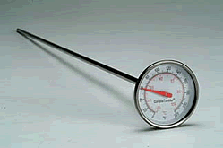
Because the heat produced during composting is directly related to the microbial activity, temperature is the primary gauge for the composting process. Abnormally low temperatures are a signal of reduced aerobic microbial activity. In most cases, a lack of oxygen is the cause. Therefore, low temperatures usually call for aeration or turning. If the windrow/pile temperature does not recover after turning or aeration, either the process is nearing completion or a problem exists.

Fig 5.1
The temperature should be monitored and recorded daily at least until the farmer acquires a strong feel for the process. The daily temperature measurements show trends in the temperature as the windrow/pile ages and suggest how often turning/aeration is required. A dial thermometer with a 1-meter stem is recommended for monitoring temperatures. The thermometer should have a temperature range of approximately 0-90°C. A pointed stem tip helps push the thermometer through dense clumps of material and lowers the chance of breaking the dial.

Oxygen-sensing equipment is occasionally used to monitor and troubleshoot composting operations. Oxygen measurements directly indicate the oxygen level within the composting materials and, therefore, provide a clue to the state of the composting process. Lower oxygen concentrations are sometimes measured during vigorous aerobic activity, and higher concentrations have been measured when conditions were clearly anaerobic. In almost all situations, temperature provides an adequate indication of the process conditions, and oxygen monitoring is not necessary. Oxygen-monitoring may be most useful in experimental situations.

Fig. 5.2

- ENVIRONMENTAL ISSUES
The composting site will determine the risk associated with odours, noise, dust, leaching, and runoff. The materials being composted, composting method and system management will also impact these environmental concerns.
Odor from the composting process is minimized through good management only if the composting system is properly designed and laid out. In setting the facility, we should consider the direction of prevailing winds during warm weather periods. Normal odors from manure are often unacceptable to the rural areas.
Consideration must be given to the noise and dust resulting from the composting operations and from transport vehicles travelling to and from the site. Grinding is a particularly noisy operation and should be performed when noise will have the least impact. Noise from site operations will extend for longer periods as the size of the operation increases. Depending upon the material being composted or the type of compost enterprise, noise may be only a seasonal factor. It is of greater concern during mild and summer weather conditions when windows are open and neighbors are outside.
Site visibility and appearance influence human perceptions. Fewer neighborhood complaints will be received if the composting site is less visible. To shield the composting site from public view, take advantage of natural landscape features such as trees and shrubs. If the site is visible to the public, it must be kept neat. Sloppy sites are perceived to have greater problems. Make use of the compost produced to landscape the site and make it attractive. Keep grass around the site mowed, control weeds, and maintain plantings in good condition.
Pollution control is a very important site consideration and is foremost on the minds of environmental regulators. Water serves as the vehicle for removing potential pollutants from the site. Rain and snow melt percolate through the materials and into the ground and/or create runoff, which can carry away pollutants. Since composting windrow/piles retain rain water, leaching is less of a concern than runoff. Therefore, emphasis at the site should be to minimize runoff and water entering the site and then handle site runoff in an environmentally safe manner.
Organic matter and ammonia can create problems in surface waters because of their oxygen consumption, which is commonly referred to as BOD or COD (biological or chemical oxygen demand). The presence of pesticides on Crop residues or heavy metals from off-farm wastes normally has a greater impact on the quality of the com post than on-site-related pollution. Other contaminants may be of concern when non-agricultural materials are composted. It is very important to know the nature of materials brought on to the farm for composting.
At a minimum, the following pollution control measures should be observed:
- Maintain windrows and piles below the maximum recommended moisture content (that is, 65%) to minimize leaching. Combine raw materials to the recommended C:N ratios to limit the loss of nitrogen. In general, follow good composting practices.
- Do not allow runoff from the composting pad and storage areas to empty directly into surface water. The runoff can be channeled to cropland or a vegetated infiltration area. Runoff can also be collected in holding ponds and later used for irrigation or as a source of moisture for dry composting materials. A sedimentation device in the runoff collection system can be used to collect solids prior to a holding pond or infiltration area.
- Divert water entering the site from uphill areas away from the composting pad and away from storage areas.
- Observe the recommended separation distances to surface and ground water.
- Store raw materials and finished compost away from surface water and drainage paths. Wet raw materials that are prone to leaching should be stored under-cover or on an impervious surface with a method to collect and safely dispose of leachate. Handle the leachate and runoff as suggested above.

- Marketing

  - Product analysis
Composting proved to be a feasible and practical alternative of manure management for farmers. It can be accomplished with existing farm equipment, with dedicated equipment and/ or controlled systems. Composting stabilizes manure and other agricultural wastes, reducing the odors, volume and other environmental impacts. If a farm is using compost fertilizer costs can be offset by improving the health of the soil.
Market of compost is an interesting business opportunity for farmers. This helps to provide valuable investments and to identify suitable products for accessible markets. Although compost is a very effective nutrient soil, which can reduce the need for chemical fertilizers, it does not guarantee a ready market. A number of factors account for this effect, including:
- lack of awareness and knowledge on how, how much and when compost is used;
- misunderstanding related with what a compost is (eg expectation to have immediate effects on soil fertility)
The marketing of the compost is important because:
- Concerns about the quality of compost produced from urban organic waste sometimes are made on the basis of negative perceptions or experiences of the past;
- The expectations of farmers to optimize performance within a short time;
- Competition with chemical fertilizers, similar products at low cost as manure;
- Transport costs are high in relation to the value of the product, as usually compost is produced far from its market;
- Regulations and policies are incomplete and not right;
  - Market positioning compost farm
Before we get enthusiast on the prospect of benefits from compost we should ask ourselves: "Where do I go to sell it?” Market of compost is a little different from other markets of agricultural products. Markets you will create will determine your success or failure. For this reason there is a need for a study of the market so that you know who your customers are, how much products your customers use, what price they are willing to pay, and what quality they want in a product before having it in their hands. You need to determine the cost of your product designed per ton.

One of the main tasks in trading compost produced on the farm is the division of agricultural compost from waste deriving compost. Compost produced from food, plants, and animal products have old and respected reputation. Promotion efforts and consumer education can effectively be raised in this regard. In addition, the regulations may restrict the use of certain solid waste compost. This creates a gap in the market to meet the agricultural compost
Compost produced on the farm occupies a position with a high quality in the market. Farmers have to keep and benefit from this marketing position. This means that the highest priority should be placed on quality control as in the production system and in the choice of raw materials.

  - Assessment and Market Development

Compost potential buyers include commercial nursery centers, the center houses and gardens, greenhouses, homeowners, farmers (fruits, vegetables, field crops, organic); schools; Individual farmers, etc. All these groups use compost or any other product that can replace chemical fertilizers.
Once you know the potential buyer, the next step is to determine the compost market. In most cases, the compost market is local, because the cost of transportation is high in comparison with other production costs.
Although transport restricts the market area, it also restricts competition. Within the local area, potential buyer’s of compost products should be contacted to determine if they will buy compost, how they will use it, and what features to expect from compost quality. Offering diversity of compost products can increase your success in the development of the target market.

User Groups | Primary Uses for Compost Products | Compost Products | Packaging
Traders
Cemeteries | Top dressing for turf, soil amendment for turf establishment and landscape plantings | Screened compost | Bulk
Discount stores, supermarkets | Resale to homeowners | General screened compost product | Bags
Garden centres, hardware/lumber outlets | Resale to homeowners and small volume users | Screened compost, mulch | Primarily bags, small-volume bulk
Greenhouses | Potting mix component, peat substitute, soil amendment for beds | High-quality, dry, screened compost | Bulk and bag
Land-reclamation contractors | Topsoil and soil amendment for disturbed landscapes (mines, urban renovation) | Unscreened compost, topsoil blend | Bulk

Table 7.1
  - Potential users and products of compost

User Groups | Primary Uses for Compost Products | Compost Products | Packaging
Agricultural and residential
Forage and field crop growers | Soil amendment, fertilizer supplement, top dressing for pasture and hay crop maintenance | Unscreened and screened compost | Bulk
Fruit and vegetable farmers | Soil amendment, fertilizer supplement, mulch for fruit trees | Unscreened and screened compost | Bulk
Homeowners | Soil amendment, mulch, fertilizer supplement, and fertilizer replacement for home gardens and lawns | Screened compost, high-nutrient compost, mulch | Primarily bags, small-volume bulk
Organic farmers | Fertilizer substitute, soil amendment | Unscreened and screened compost, high-nutrient compost | Primarily bulk
Turf growers | Soil amendment for turf establishment, top, dressing | Screened compost topsoil blend | Bulk

Table 7.2

User Groups | Primary Uses for Compost Products | Compost Products | Packaging
Communal (potential for the future)
Landfills | Landfill cover material, primarily final cover | Unscreened low quality compost | Bulk
Schools, park and recreation departments | Topsoil for road and construction work, soil amendment and mulch for landscape plantings | Unscreened and screened compost, topsoil blend | Bulk
Public works departments | Topsoil, top dressing for turf and ball fields, soil amendment and mulch for landscape plantings | Screened compost, topsoil blend, mulch | Bulk

Table 7.3

Although the characteristics that users require of compost vary with the specific use, compost users generally share several common expectations. These are listed below, roughly in their order of importance:
- Quality - Quality compost is probably the number one requirement from the user's standpoint. It is not enough just to make compost. You have to make quality compost-not the kind of compost product you are capable of producing but the kind that the customer wants. A user's judge of quality depends on the ultimate use. But common criteria include moisture; odor; feel; particle size; stability; nutrient concentration; and a lack of weed seeds, phytotoxic compounds, and other contaminants. A consistently stable product is particularly important; just one bad lot of compost will turn away customers forever if it harms their plants.
- Price - The price must be generally competitive with other composts and compost substitutes (top soil, peat moss, and so on), though a higher price can be offset by high quality and performance.
- Color/texture/odor - Users expect compost to be uniform in texture and relatively dry (that is, less than 50% moisture) and to have an earthy color and odor.
- Informacioni - Shumica e klientave potencial nuk i njohin mirë karakteristikat e kompostit. Të paktën në fillim, ata duan dhe i nevojitet informacion për avantazhet dhe si ta përdorin. Shumë përdorues gjithashtu duan informacion rreth kohës dhe mënyrës së përdorimit të tij.
- Information - Most potential customers are unfamiliar with compost's characteristics. At least initially, they want and need information about its benefits and how to use it. Many users also desire information about application rates and application procedures.
- Reliable supply - Customers expect a reliable supply, especially if they have been given a commitment.

  - Bag versus Bulk Sales
One of the first marketing questions to consider is how to sell compost – in bulk, in bags, or in both. Bags accommodate customers who need compost in small quantities and are conveniently handled at retail outlets. Bagged products also sell at a considerably higher price than most bulk compost. The higher price justifies higher transportation costs and, therefore, a larger market area. Quality control is also more critical since the compost remains in plastic bags for a relatively long time.
The bulk market is found to be a more favourable arena in which to participate. Transportation costs keep the bulk market at a very local level, so relatively small producers can compete. Compost could be offered in bulk right from your farm. If you expect to produce a large volume of compost, you will need to spend more time developing firm markets that will be reliable customer year-after-year.

  - Selling your product
Compost marketing can be a minor or major task, depending on the amount, quality, appearance, and seasonal availability of the product. Most compost is used in the spring and early summer. Your product must be stable and suitably dry for delivery at that time. A consistently high-quality product is critical to the marketing effort. If a problem should occur with a customer using your product, you must remedy the situation immediately, both with the production process and with the unsatisfied customer.
Since you will be offering a product with some very unique characteristics, it is important that you know and stress those points when offering your product to customers. What are those characteristics?
- Compost is usually pH-neutral, which means it will neither add to nor detract from the acidity or alkalinity of soils.
- Compost is a soil amendment. Though it does contribute substantial nutrients to the soil, it should not be compared to chemical fertilizers.
- Compost is one of the best sources of organic matter available. When organic matter is added to soils, the water- and nutrient-holding capacity is increased, providing plants with superior growing conditions.
- As the organic matter of compost decomposes, it slowly releases its nutrients to plants. It will not burn plants the way chemical fertilizers can. The nutrients and other beneficial effects of compost last for several years.
- The organic matter in compost acts like a sponge, retarding the loss of moisture and nutrients from fertilizers, holding them available in the plant root zone.
- Properly made compost is nearly free of weed seeds-a big selling point. But it can also hurt your credibility if you cannot produce weed-free compost.
- Farm compost is made primarily from livestock manures and plant materials, not from sewage sludge or solid wastes. Customers may be concerned with what materials are used in making compost.
- Composting is an environmentally beneficial process, and compost is an ecologically sound product.
Emphasizing the positive benefits of compost will normally be sufficient to convince a prospective customer of its value. The fact that compost is made from recycled by-products is also helpful. To convince sceptical customers, use your products in demonstration plots and gardens. Offer compost as a valuable resource, not as a treated waste material, although customers may gain satisfaction in participating in a recycling effort.

  - Cost of composting
Any farmer starting to assess the likely costs of a composting operation should ask a few basic questions.
First and perhaps most importantly, what quantity of appropriate organic materials are available to compost, and at what price? Many, if not most farmers have the potential to compost significant amount of material without significant new costs. Larger volumes require increasingly substantial commitments of land, labor, and/or capital investment.
Second, what kinds of on and off-farm materials are available? Preferable on-farm candidates are uncontaminated organic waste materials that have significant handling or disposal costs whether composted or not. Preferable off-farm materials are those that come with a tipping fee and complement the important physical characteristics (carbon to nitrogen ratio, moisture content, particle size, etc.) of on-farm compostables. Nutrient rich, wet farm manures and clean municipal leaves that come with a tipping fee are an attractive combination. Usually, the farmer will not have to purchase any compost "ingredients". However, even on-farm compostables may impose significant additional handling costs if the compost site is not conveniently located.
Third, how much land can the farmer devote to composting? Composting can be land hungry. Farmers serious about composting are likely to want at least an acre of unused or underutilized land with suitable slope, drainage, and access. The amount of such land available, in conjunction with the amount of material to be composted, will be a driving force behind the cost of necessary compost technology. Depending on the technology used, an acre can handle from two or three thousand cubic meters to several tens of thousands of cubic meters of compostables per year. Should scarce land be valued at many thousands of lek per acre, then sensible farm composters handling significant quantities of material will need to invest in the capital equipment that allows them to minimize their use of land.
Fourth, what are the expected markets or uses for the finished compost? The production of compost to meet the needs of a specialty or high value market calls for particularly rigorous controls in order to keep out or remove incoming contaminants (both physical and chemical). Capital investment in improving the final product through shredding or screening is important. Marketing expertise is also required, along with associated marketing costs. These costs are likely to significantly exceed the costs of applying finished compost to farm land, and many farmers will prefer to simplify their compost systems and take advantage of the benefits of adding compost to their own soils. Much of the expensive extra processing does little to add value to the compost from the point of view of a farm application.
In reality the costs of any particular compost operation depend on a large number of additional specific variables, many of which will vary from farm to farm. An extensive but not exhaustive list of the variables of importance includes the local costs of labor, fuel prices, the value of land and the cost of purchasing and maintaining equipment. The type and volumes of material handled can differ according to the type and size of farm and the character of nearby communities. The choice of compost technology, alternative manure handling practices, and the extent of necessary site preparation depend on farm specific circumstances. Several location factors can have strong influences on costs. These include proximity to neighbors, the distance to off-farm sources of compostable materials, and the distances compostables generated on-farm must be moved first to the compost site or later from the compost site to the point of final use. Further variation can be expected in the need for local or state permits, interest rates and credit terms, the quality of product desired by the end-user, and so forth.
Different factors will come into play at different stages of the compost process. Typically before start-up, the composting operation must be planned, potential markets identified, and any necessary permits obtained. A site must be prepared and any new equipment acquired. Once normal operations begin, materials handling processes dominate. All materials to be composted must be delivered to the compost site: transportation to a compost site on a remote field can be costly even for materials generated on farm. Many materials will require a pre-processing effort that ranges from contaminant removal to particle size reduction including grinding, chipping, shredding or chopping. The materials must be mixed together, ideally approximating a homogeneous mixture with optimal carbon/nitrogen ratios, porosity, and moisture content. Next, or simultaneously, the initial piles must be formed considering the appropriate size, shape and location for the technology used. Routine aeration and/or continued mixing of the piles ensue, with consolidation of windrowed piles as volume reduces. Water may need to be added to dry piles. Some degree of monitoring of the piles is required to ensure that composting is proceeding as expected.
At the economic center of the composting process are the expenditures for the land, labor and equipment that are needed to physically transform the manures and other compostable materials into a stabilized compost product. While there are other costs that may be substantial (e.g. moving compostables to the compost site), it is the costs of managing the compost piles themselves that are most distinctive to compost operations. Fortunately, desirable composts can be produced using technologies or management systems that employ different combinations of land, labor and equipment, thus allowing the farmer to emphasize use of the factors least costly to him or her.
As suggested earlier, more intensive (and expensive) management systems are able to handle more material in a given land area, largely by increasing the speed of stabilization and volume reduction and decreasing the time required to produce finished compost. Thus, as volumes of material to be composted increase, the tendency is to increasingly devote a greater proportion of total production costs first to increased labor and then to more sophisticated composting equipment.
Depending on the scale of operation and the technology adopted, initial outlays for site preparation, planning, and permitting, plus any other investment in equipment and the site, can range from a few hundred leks to a significant amount of leks. Though very large quantities of material and materials that are relatively difficult to compost without problems often require a more costly management system, the greater expense buys substantially greater annual production capacity. A key to minimizing costs per ton is scaling the operation to make possible the efficient utilization of costly fixed investments like specialized composting equipment or land.

- ANNEXES

BIBLIOGRAPHY
Adi, A. J., & Noor, Z. M. (2009). Waste recycling: Utilization of coffee grounds and kitchen waste in vermicomposting. Bioresource Technology, 100(2), 1027-1030. http://dx.doi.org/10.1016/j.biortech.2008.07.024
Bhadauria, T., &Ramakrishnan, P. S. (1996). Role of earthworms in nitrogen cycling during the cropping phase of shifting agriculture (Jhum) in north-east India. Biology and Fertility of Soils, 22(4), 350-354. http://dx.doi.org/10.1007/BF00334582
Chan, P. L. S., &Griffits, D. A. (1988). The vermicomposting of pre-treated pig manure. Biological Wastes, 24(1), 57-69. http://dx.doi.org/10.1016/0269-7483(88)90027-4
Edwards, C.A. (1999). Interview with Dr. Clive Edwards - part two. Casting Call, 4(2): 3-7. Environmental Planning and Assessment Act (1979). New South Wales Consolidated Acts. Internet publication: http://www.austlii.edu.au/au/legis/nsw/consol_act/epaaa1979389/
Frederickson, J., & Howell, G. (2003). Large-scale vermicomposting: emission of nitrous oxide and effects of temperature on earthworm populations: The 7th international symposium on earthworm ecology, Cardiff, Wales, 2002. Pedobiologia, 47(5-6), 724-730. http://dx.doi.org/10.1078/0031-4056-00250
Garg, P., Gupta, A., & Santosh, S. (2006). Vermicomposting of different types of waste using Eiseniafoetida: A comparative study. Bioresource Technology, 97(3), 391-395. http://dx.doi.org/10.1016/j.biortech.2005.03.009
Garg, V. K., Suthar, S., & Yadav, A. (2012). Management of food industry waste employing vermicomposting technology. Bioresource Technology, 126, 437-443. http://dx.doi.org/10.1016/j.biortech.2011.11.116
Ghosh, M., Chattopadhyay, G. N., &Baral, K. (1999). Transformation of phosphorus during vermicomposting. Bioresource Technology, 69(2), 149-154. http://dx.doi.org/10.1016/S0960-8524(99)80001-7
Ivask, M., Olle, L., &Nei, L. (2013). Domestic organic waste treatment through vermitechnology. Waste Management & Research, 31(8), 878. http://dx.doi.org/10.1177/0734242X11403798
Kaushik, P., & Garg, V. K. (2004). Dynamics of biological and chemical parameteres during vermicomposting of solid textile mill sludge mixed with cow dung and agricultural residues. Bioresource Technology, 94(2), 203-209. http://dx.doi.org/10.1016/j.biortech.2003.10.033
Lillenberg, M., Yurchenko, S., Kipper, K., Herodes, K., Pihl, V., Lohmus, R., Nei, L. (2010). Presence of fluoroquinolones and sulfonamides in urban sewage sludge and their degradation as a result of composting. International Journal of Environmental Science and Technology, 7(82), 307-312. http://www.ijest.org/jufile?c2hvd1BERj00MDE=&ob=1ac5df118387d2eb0fb46ab4044301c6&fileName=f ull_text.pdf
New South Wales Consolidated Acts. Internet publication: http://www.austlii.edu.au/au/legis/nsw/consol_act/poteoa1997455/
Parthasarathi, K., &Ranganathan, L. S. (2000). Aging effect on enzyme activities in pressmudvermicasts of Lampitomauritii (Kinberg) and Eudriluseugeniae (Kinberg). Biology and Fertility of Soils, 30(3), 347-350. http://dx.doi.org/10.1007/s003740050014
Recycled Organics Unit (2000).Processing of Commercial and Industrial Organics in Vermiculture Systems. Report for Southern Sydney Waste Board. Recycled Organics Unit, internet publication: www.recycledorganics.com
Recycled Organics Unit (2001a). Recycled Organics Industry Dictionary & Thesaurus: standard terminology for the NSW recycled organics industry. Second Edition. Recycled Organics Unit, internet publication: http://www.rolibrary.com
Recycled Organics Unit (2001b). Greenhouse Gas Emissions from Composting Facilities. Report for Central Coast Waste Board, Recycled Organics Unit, internet publication: www.recycledorganics.com
Recycled Organics Unit (2001c). Food Organics Processing Options for New South Wales. Report for Central Coast Waste Board, Recycled Organics Unit, internet publication: www.recycledorganics.com
Recycled Organics Unit (2001e). Establishing a Licensed Composting Facility: A guide to siting, designing, gaining approval and a licence to develop and operate a composting facility in New South Wales. Recycled Organics Unit, internet publication: www.recycledorganics.com
Recycled Organics Unit On-site Composting: Technology Options and Process Control Strategies Page 50 3rd Edition 2007
Recycled Organics Unit (2001f). Best Practice Guideline to Managing On-Site Vermiculture Technology. Recycled Organics Unit, internet publication: www.recycledorganics.com
Recycled Organics Unit (2001g). Producing Quality Compost: Operation and management guide to support the consistent production of quality compost and products containing recycled organics. Recycled Organics Unit, internet publication: www.recycledorganics.com
Recycled Organics Unit (2001h). Composting Science for Industry: An overview of the scientific principles of composting processes. Recycled Organics Unit, internet publication: www.recycledorganics.com
Sharma, S., Pradham, K., Satya, S., &Vasudevan, P. (2005). Potentiality of earthworms for waste management and in other use - A Review. The Journal of American Science, 1(1), 4-16. Nxjerrëngahttp://www.jofamericanscience.org/journals/am-sci/0101/02-sharma.pdf
Suthar, S., & Singh, S. (2008). Vermicomposting of domestic waste by using two epigeic earthworms (Perionyxexcavatus and Perionyxsansibaricus). International Journal of Environmental Science and Technology, 5(1), 99-106. Retrieved from http://www.ijest.org/?_action=articleInfo&article=197
Tremier, A., de Guardia, A., Massiani, C., Paul, E., & Martel, J. L. (2005). A respirometric method for characterising the organic composition and biodegradation kinetics and the temperature influence on the biodegradation kinetics, for a mixture of sludge and bulking agent to be co-composted. Bioresource Technology, 96(2), 169-180. http://dx.doi.org/10.1016/j.biortech.2004.05.005
Vinceslas-Apka, M., &Loquet, M. (1997). Organic matter transformations in lignocellulosic waste products composted or vermicomposted (Eiseniafetidaandrei): chemical analysis and 13C CPMAS NMR spectroscopy. Soil Biology & Biochemistry, 29(3), 751-758. http://dx.doi.org/10.1016/S0038-0717(96)00201-5
Yousefi, J., Younesi, H., &Ghasempoury, S. M. (2013). Co-composting of municipal solid waste with sawdust: improving compost quality. Clean – Soil Air Water, 41(2), 185-194. http://dx.doi.org/10.1002/clen.201100315

SITOLOGJIA
- http://www.riciklimi.al/legjislacioni.php
- http://www.riciklimi.al/publikimet.php
- http://www.agf.gov.bc.ca/resmgmt/publist/300Series/382500-2.pdf
- http://anrcatalog.ucdavis.edu/pdf/8367.pdf
- http://www.biocycle.net/2004/01/30/practicalities-of-compost-marketing-and-sales/
- http://www.bplans.com/recycling_waste_materials_business_plan/market_analysis_summary_fc.php
- http://www.calrecycle.ca.gov/organics/compostmulch/CompostIs.htm
- http://www.compost.org/pdf/compost_proc_tech_eng.pdf
- http://compostingcouncil.org/compost-benefits-uses-markets/
- http://www.cre.ie/web/wp-content/uploads/2010/12/Rx3-Compost-Market-Report-Nov-2012.pdf
- http://cwmi.css.cornell.edu/compostfs1.pdf
- http://www2.epa.gov/recycle/composting-home
- http://www.epa.gov/region4/rcra/mgtoolkit/documents/masteringoperationsandmarketing.pdf
- http://eartheasy.com/grow_compost.html
- http://www.fao.org/docrep/007/y5104e/y5104e05.htm
- http://www.gardeningknowhow.com/composting/basics/garden-compost-benefits.htm
- http://www.health.state.mn.us/divs/eh/risk/studies/metals.html
- http://www.homecompostingmadeeasy.com/compoststages.html
- http://www.leeds.gov.uk/docs/How%20to%20compost.pdf
- http://nerc.org/documents/compost_marketing/making_your_compost_product_work_for_you.pdf
- http://organiclifestyles.tamu.edu/compost/home_composting_faq.pdf
- http://www.rodalesorganiclife.com/files/soil1jpg
- http://www.rodalesorganiclife.com/garden/fast-cooking-compost-pile
- http://www.planetnatural.com/composting-101/
- http://www.recyclenow.com/reduce/home-composting
- http://www.recyc-quebec.gouv.qc.ca/Upload/publications/Mici/j-mat-org-14-mars-2012/4a-Ron-Alexander.pdf
- http://study.com/academy/lesson/what-is-composting-definition-and-examples.html
- http://www.sswm.info/sites/default/files/reference_attachments/ROUSE%20et%20al%202008%20Marketing%20Compost.pdf
- http://www.thisoldhouse.com/toh/photos/0,,20232973,00.html
- http://whatcom.wsu.edu/ag/compost/fundamentals/benefits_benefits.htm
- http://whatcom.wsu.edu/ag/compost/pdfs/marketing%20guide.pdf
- http://www.wikihow.com/Compost

